**Storage Devices**

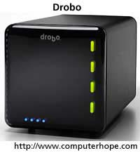

Alternatively referred to as digital storage, storage, storage media, or storage medium, a storage device is any [hardware](https://www.computerhope.com/jargon/h/hardware.htm) capable of holding information either temporarily or permanently. The picture shows an example of a [Drobo](https://www.computerhope.com/jargon/d/drobo.htm), an external secondary storage device.

There are two types of storage devices used with computers: a [primary storage](https://www.computerhope.com/jargon/p/primstor.htm) device, such as [RAM](https://www.computerhope.com/jargon/r/ram.htm), and a storage device, like a [hard drive](https://www.computerhope.com/jargon/h/harddriv.htm). Secondary storage can be [removable](https://www.computerhope.com/jargon/r/remodisk.htm), [internal](https://www.computerhope.com/jargon/i/internal.htm), or [external](https://www.computerhope.com/jargon/e/external.htm) storage.

Examples of computer storage

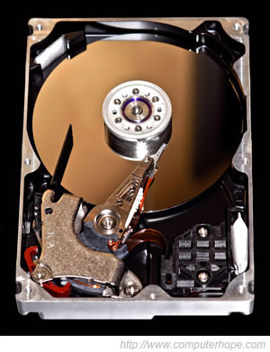

**Magnetic storage devices**

Today, [magnetic storage](https://www.computerhope.com/jargon/m/magnmedi.htm) is one of the most common types of storage used with computers and is the technology that many computer hard drives use.

* [Floppy diskette](https://www.computerhope.com/jargon/f/fdd.htm)
* [Hard drive](https://www.computerhope.com/jargon/h/harddriv.htm)
* [Magnetic strip](https://www.computerhope.com/jargon/m/magncard.htm)
* [SuperDisk](https://www.computerhope.com/jargon/s/superdisk.htm)
* [Tape cassette](https://www.computerhope.com/jargon/t/tape.htm)
* [Zip diskette](https://www.computerhope.com/jargon/z/zipdrive.htm)

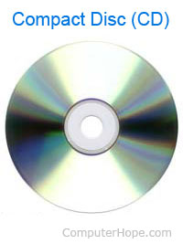

**Optical storage devices**

Another common storage is [optical storage](https://www.computerhope.com/jargon/o/optidisc.htm), which uses lasers and lights as its method of reading and writing data.

* [Blu-ray disc](https://www.computerhope.com/jargon/b/bd.htm)
* [CD-ROM disc](https://www.computerhope.com/jargon/c/cdrom.htm)
* [CD-R and CD-RW disc](https://www.computerhope.com/jargon/c/cdr.htm)
* [DVD-R, DVD+R, DVD-RW, and DVD+RW disc](https://www.computerhope.com/jargon/d/dvdr.htm)

**Flash memory devices**

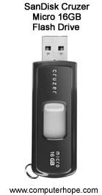

[Flash memory](https://www.computerhope.com/jargon/f/flashmem.htm) has started to replace magnetic media as it becomes cheaper as it is the more efficient and reliable solution.

* [USB flash drive, jump drive, or thumb drive](https://www.computerhope.com/jargon/j/jumpdriv.htm)
* [Memory card](https://www.computerhope.com/jargon/m/memocard.htm)
* [Memory stick](https://www.computerhope.com/jargon/m/memstick.htm)
* [SSD](https://www.computerhope.com/jargon/s/ssd.htm)

**Online and cloud**

Storing data online and in cloud storage is becoming popular as people need to access their data from more than one device.

* [Cloud storage](https://www.computerhope.com/jargon/c/cloudcom.htm)
* [Network media](https://www.computerhope.com/jargon/n/network-media.htm)

**Paper storage**

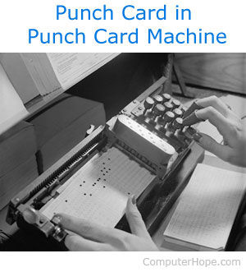

Early computers had no method of using any of the above technologies for storing information and had to rely on paper. Today, these forms of storage are rarely used or found. In the picture to the right is an example of a woman entering data to a punch card using a punch card machine.

* [OMR](https://www.computerhope.com/jargon/o/omr.htm)
* [Punch card](https://www.computerhope.com/jargon/p/punccard.htm)

Why is storage needed in a computer?

Without a storage device, a computer cannot savior remember any settings or information and would be considered a [dumb terminal](https://www.computerhope.com/jargon/d/diskwork.htm).

Although a computer can run with no storage device, it would only be able to view information unless it was connected to another one that had storage capabilities.

Why so many different storage devices?

As computers advance so do the requirements for storage space and the technologies used to store data. Because people need more and more space, want it faster, cheaper, and want to take it with them new technologies have to be invented. When new storage devices are designed, as people upgrade to those new devices the older devices are no longer needed and stop being used.

For example, when punch cards were first used in early computers the magnetic media used for floppy disks was not available. After floppy diskettes had been released, they were replaced by CD-ROM drives, which were replaced by DVD drives, which have been replaced by flash drives. The first [hard disk drive](https://www.computerhope.com/jargon/h/harddriv.htm) from IBM cost $50,000, was only 5 MB, was big, and cumbersome. Today, we have [smartphones](https://www.computerhope.com/jargon/s/smartphone.htm) that have hundreds of times the capacity at a much smaller price that we can carry with us in our pocket.

Each advancement of storage devices gives a computer the ability to store more data, save data faster, and access the saved data faster.

What is a storage location?

When [saving](https://www.computerhope.com/jargon/s/save.htm) anything on a computer, it may ask you for a storage location, which is the area in which you would like to save the information. By default, most information is saved to your computer hard drive. If you want to move the information to another computer, save it to a removable storage device such as a [flash drive](https://www.computerhope.com/jargon/j/jumpdriv.htm).

What storage devices are used today?

Most of the storage devices mentioned earlier are no longer used with today's computers which primarily use a hard disk drive or SSD to store information and have the options for USB flash drives and access to cloud storage. Desktop computers with disc drives typically use a disc drive that is capable of reading CD's and DVD's and writing CD-R and other recordable discs.

What storage device has the largest capacity?

For most computers, the largest storage device is the [hard drive](https://www.computerhope.com/jargon/h/harddriv.htm) or [SSD](https://www.computerhope.com/jargon/s/ssd.htm). However, networked computers may also have access to larger storage with large [tape drives](https://www.computerhope.com/jargon/t/tape.htm), [cloud computing](https://www.computerhope.com/jargon/c/cloudcom.htm), or [NAS](https://www.computerhope.com/jargon/n/nas.htm) devices. Below is a list of storage devices from the smallest capacity to the largest capacity.

Note: Many storage devices have been available in many different capacities. For example, over the evolution of the hard drive, there have been drives that range from the first hard drive of 5 [MB](https://www.computerhope.com/jargon/m/megabyte.htm) to hard drives today that are several [terabytes](https://www.computerhope.com/jargon/t/terabyte.htm) in size. Therefore, the below list is only meant to give a general understanding of the size differences between each storage devices *today* and is not an exact list. For example, the earliest hard drives are smaller than a CD.

1. [Punch card](https://www.computerhope.com/jargon/p/punccard.htm)
2. [Floppy diskette](https://www.computerhope.com/jargon/f/floppydi.htm)
3. [Zip disk](https://www.computerhope.com/jargon/z/zipdrive.htm)
4. [CD](https://www.computerhope.com/jargon/c/cd.htm)
5. [DVD](https://www.computerhope.com/jargon/d/dvd.htm)
6. [Blu-ray disc](https://www.computerhope.com/jargon/b/bd.htm)
7. [Flash jump drive](https://www.computerhope.com/jargon/j/jumpdriv.htm)
8. [Hard drive](https://www.computerhope.com/jargon/h/harddriv.htm) / [SSD](https://www.computerhope.com/jargon/s/ssd.htm)
9. [Tape drive](https://www.computerhope.com/jargon/t/tape.htm)
10. [NAS](https://www.computerhope.com/jargon/n/nas.htm) / [Cloud Storage](https://www.computerhope.com/jargon/c/cloudcom.htm)

Are storage devices input and output devices?

No. Although these devices do send and receive information, they are not considered an [input device](https://www.computerhope.com/jargon/i/inputdev.htm) or [output device](https://www.computerhope.com/jargon/o/outputde.htm). It is more proper to refer to any device capable of storing and reading information from a storage device, [disk](https://www.computerhope.com/jargon/d/disk.htm), [disc](https://www.computerhope.com/jargon/d/disc.htm), or a [drive](https://www.computerhope.com/jargon/d/drive.htm).